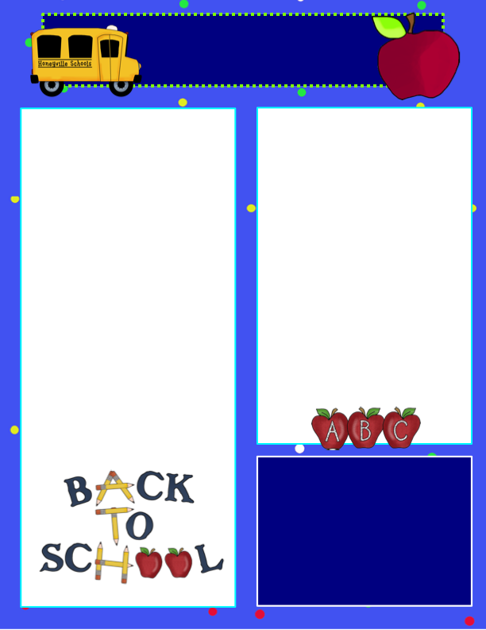

**Welcome to Kindergarten!**

We are very excited to be your child’s teacher this year and have been very busy setting up our classroom and getting it ready for our first day of school. Pony Prep runs August 3rd through August 13th; Monday-Thursday 8:30-11:30. During this time your child will meet their teachers and peers, and work on back to school basics to get them ready for the school year. We look forward to meeting you.  We hope are as excited about school as we are and have enjoyed a wonderful summer.

FIRST DAY OF SCHOOL

SEPTEMBER 1, 2015

Be sure to pack a smile and be ready to have a super awesome school year, filled with unforgettable memories!



Kindergarten Connection

**August 2015**

**Dates to Remember**

August 3rd-Pony Prep Begins

August 6th School Registration  
August 11th School Registration

***August 19th- Kindergarten Parent Night***

August 27th- Open House

September 1st- First day of School

**A Little About Us…**

Ms. Gobel and Ms. Mentz are the Kindergarten teachers, we do a lot of fun things together and create a family amongst our classrooms.

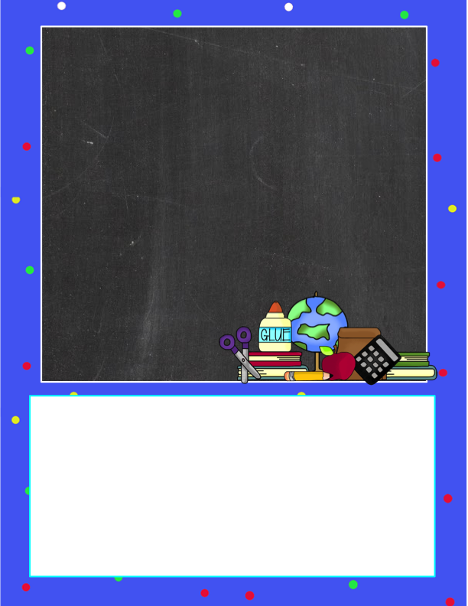

Spoons

Kleenex’s (we could always use more)

Paint Brushes  
iTunes Gift Card (for educational apps)

Shaving Cream (unscented)

Cups (plastic, paper, Styrofoam)

Forks

Play-Doh

White Rice

Spaghetti Noodles

Yarn

White Glue

Pipe Cleaners

Tissue Paper

Sanitizing Wipes/ Lysol Wipes

Kindergarten Wish List

Contact Information:

Ms. Mentz- *phone:608-938-2707*  *Email:* [*mentzal@monticello.k12.wi.us*](mailto:mentzal@monticello.k12.wi.us)

Ms. Gobel- phone: 608-938-2723

Email: gobelje@monticello.k12.wi.us

We will be having a classroom website that only parents can view. Please provide the teachers with a valid email, because we will be sending weekly reminders and pictures to this email.